新闻稿

上海，2019年10月9日
__________________________________________________________

Two Swiss Scientists awarded the Nobel Prize in Physics
两位瑞士科学家荣获2019诺贝尔物理学奖

On October 8, 2019, Swiss scientists Michel Mayor and Didier Queloz were jointly awarded the Nobel Prize in Physics, together with Canadian-American James Peebles for their groundbreaking work on cosmology and exoplanet.
2019年10月8日，瑞士科学家Michel Mayor和Didier Queloz与加拿大裔美国人James Peebles因其在宇宙学和系外行星方面的开创性工作而共同获得诺贝尔物理学奖。
09.10.2019, Shanghai, China – On Oct 10th, 2019, The Royal Swedish Academy of Sciences in Stockholm announced that Swiss scientists Michel Mayor and Didier Queloz from the University of Geneva have been jointly awarded the US$ 910,000 prize with Canadian-American cosmologist James Peebles, Princeton University. "This year's Nobel Prize in Physics rewards new understanding of the universe's structure and history, and the first discovery of a planet orbiting a solar-type star outside our solar system," according to the Nobel committee, "the discoveries have forever changed our conceptions of the world."
2019年10月9日，上海 ——2019年10月8日瑞典皇家科学院公布将2019年诺贝尔物理学奖授予来自日内瓦大学的瑞士科学家Michel Mayor和Didier Queloz以及普林斯顿大学的加拿大裔美国宇宙学家James Peebles，他们将共同获得约91万美元的奖金。诺贝尔委员会表示：“他们改变了人们对宇宙结构和历史的新认识，并且首次发现了围绕其他类太阳恒星运行的系外行星。这些发现将永远改变我们对世界的认识。”

“Simply extraordinary” “简直非同寻常”
Astrophysicist Michel Mayor, 77, and astronomer Didier Queloz, 53, both of the University of Geneva, were honored for their discovery of the first exoplanet — a planet outside our solar system that orbits a sun-like star. Back in October 1995, they sparked a revolution in the search for life elsewhere in the universe when they discovered 51 Pegasi B, a gaseous ball comparable with Jupiter at time when, “no one knew whether exoplanets existed or not.”
日内瓦大学77岁的天体物理学家Michel Mayor和53岁的天文学家Didier Queloz因发现第一个系外行星而被授予奖项。系外行星是太阳系外的行星，它绕类太阳恒星运行。早在1995年10月，他们发现与木星相似的气态星体飞马座51b（51 Pegasi B），当时引发了一场在宇宙其他地方寻找生命的革命，当时“没人知道系外行星是否存在”。
Mayor and Queloz were able to find the exoplanet using a sophisticated technique known as Doppler spectroscopy, which measures the tiny wobble of a star that occurs as the star-planet pair move around a common center of gravity. This wobbling movement alternately blueshifts and redshifts the light from the star.
Mayor和Queloz通过利用多普勒光谱仪的技术找到系外行星，该技术可以测量在一对行星围绕共同重心移动时恒星发生的微小摆动。这种摆动交替地使来自恒星的光发生蓝移和红移。
“This discovery is the most exciting of our entire career, and to be awarded a Nobel Prize is simply extraordinary,” Mayor and Queloz in a statement on Tuesday. “Maybe we can discover some form of life, we don't know what kind of form." Scientists have now identified more than 4,000 exoplanets, which are deemed by scientists have good conditions for life.
“这一发现是我们整个职业生涯中最激动人心的，能获得诺贝尔奖也非同寻常” Mayor和Queloz在周二的一份声明中说道， “也许我们可以发现某种形式的生命，但我们不知道哪种形式。”科学家目前已发现4000多颗有支持生命条件的系外行星。
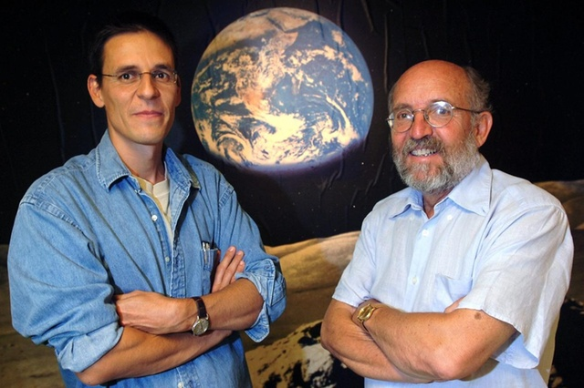
两位来自瑞士的诺贝尔奖获得者Didier Queloz 和 Michel Mayor在2005年的合照
(图片Keystone / Laurent Gillieron)

Swiss Excellence in Education and Innovation
瑞士卓越的教育与创新
The Nobel Prize in Physics is widely regarded as the world’s most prestigious award and is often a strong indicator of outstanding research on a national level.
诺贝尔物理学奖被广泛认为是世界上最负盛名的奖项，是国家研究能力的有力风向标。
Switzerland, renowned for its research, occupies a top position on the Nobel Prize charts with 28 Nobel Prizes (21 Scientific) awarded since 1901. The small alpine country boasts 32.77 Nobel laureates per 10 million inhabitants, dwarfing the United States’ 11.48 and the European Union’s average of 9.44. Among these Swiss scientists was Albert Einstein, who received the 1921 Nobel Prize in Physics for his contributions to theoretical physics.
瑞士以其研究而著称，在诺贝尔奖榜上名列前茅，自1901年以来共获得瑞士共获得28项诺贝尔奖（21项科学类奖项）。这个坐落在阿尔卑斯山的小国每1000万居民就拥有32.77诺贝尔奖得主，相比之下美国的平均值为11.48和欧盟为9.44。这些瑞士科学家中就包括著名的阿尔伯特·爱因斯坦，他因对理论物理学的贡献而获得1921年诺贝尔物理学奖。
Switzerland is able to consistently hold leading positions in international education, research and innovation indicators thanks to its world-class higher education and research institutions, supported by a robust economy and favorable governmental policies.
瑞士能够在国际教育、研究和创新领域始终保持领先地位，得益于其世界一流的高等教育和研究机构以及有力的经济和政府政策支持下。
######

About swissnex China
关于瑞士联邦政府科技文化中心
swissnex China is the Science Consulate of Switzerland in China, which builds bridges by connecting Switzerland and China in education, research and innovation. By crossing conventional boundaries, we offer a platform to foster collaboration and creativity for inspiring research and ground-breaking innovation.
瑞士联邦政府科技文化中心（swissnex China）是瑞士驻中国科学领事馆，旨在搭建瑞士和中国在教育、研究和创新方面交流的桥梁。我们跨越地理的界限，为合作和创新提供平台，以研究和突破性的创新。

swissnex China official website: https://www.swissnexchina.org/

swissnex China LinkedIn: https://www.linkedin.com/company/swissnex-china/

swissnex China Weibo: https://weibo.com/swissnexchina

swissnex China Twitter: https://twitter.com/swissnexChina

Media contact

Mr. Danli ZHOU

Head of Marketing & Communications

swissnex China

Tel: + 86 21 6235 1889

Email: danli.zhou@swissnexchina.org

