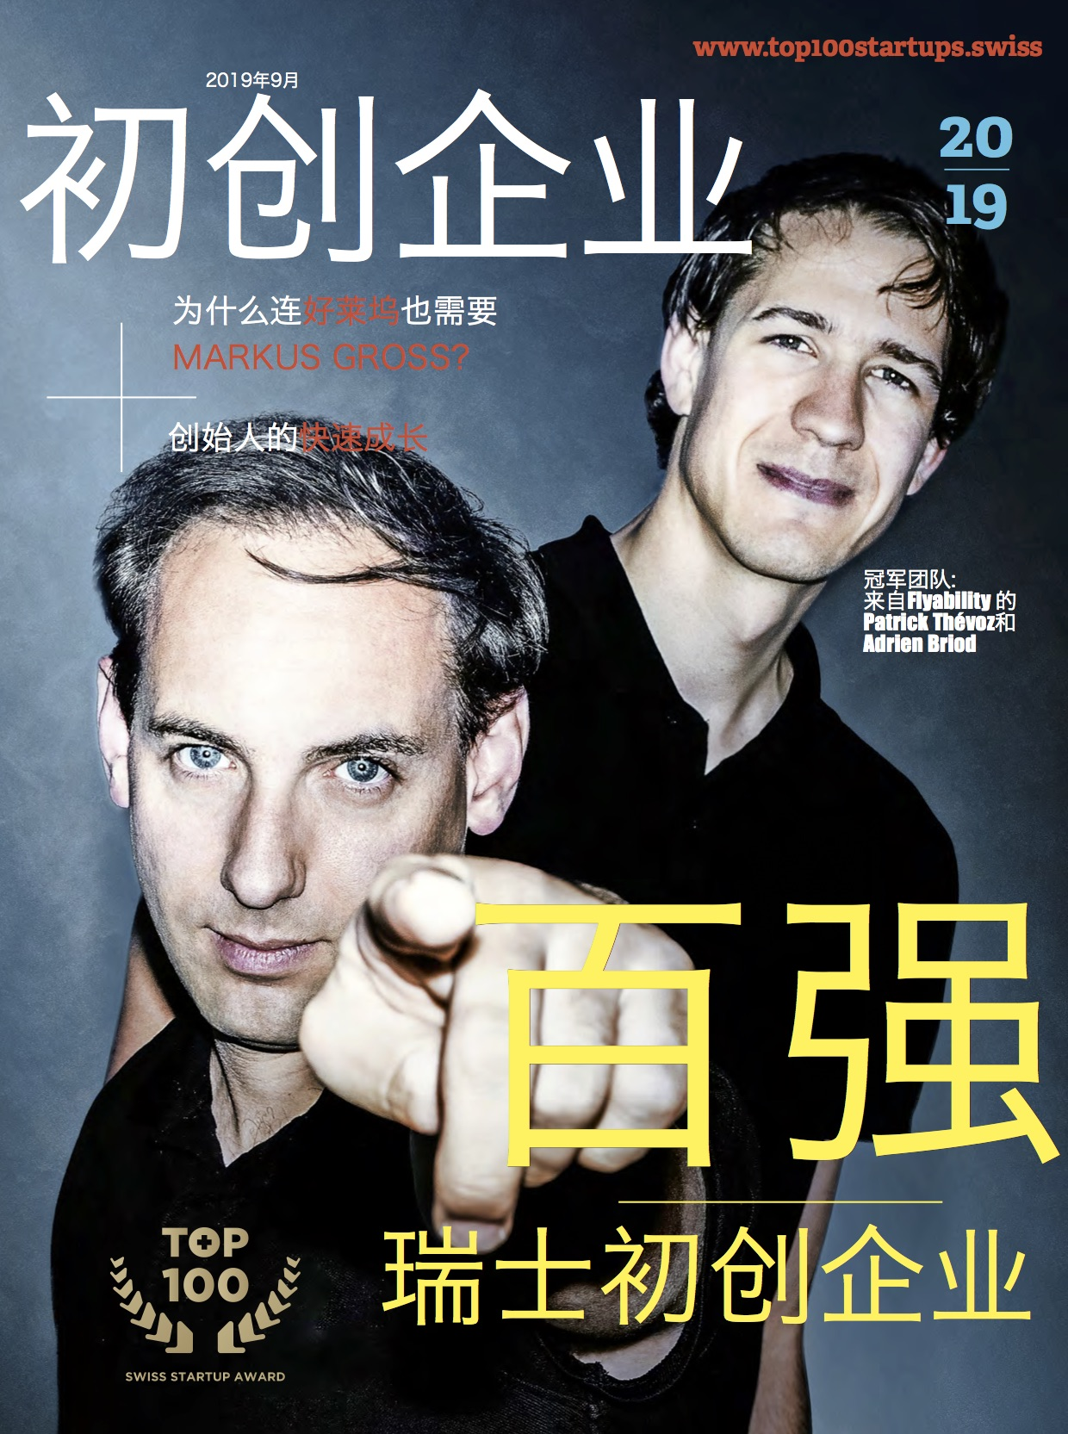
Feature Article

Chinese Edition of Top 100 Swiss Startup 2019 Magazine Released

On October 16, 2019, the Chinese edition of Top 100 Swiss Startup Magazine is officially released, which is made possible with the support from Changzhou National Hi-Tech District (CND) and Shanghai Blockchain Technology Association. The Top 100 Swiss Startup organized by Venturelab is the annual reference on the world shapers of tomorrow comprising leading Swiss startups and entrepreneurs, many of whom are already active in international markets.

Each year since 2011, the 100 most innovative and promising Swiss startups are picked by a jury of 100 leading investors and startup experts. The selected TOP 100 startups are the world shapers of tomorrow. So far 397 start-ups have ranked in the TOP 100 and to date they have attracted nearly CHF 4.3 billion in investment.

TOP 3 in 2019: the ultimate rivalry
This year’s All TOP3 winners participated in the Venture Leaders China program co-organized by Venturelab and swissnex China: Flyability, Lunaphore, Ava Women. The 2019 edition will be their last appearance in the TOP 100, having reached the age-limit of five years for the ranking.
Winner Flyability (4th last year), with more than 350 customers across global markets, the EPFL-spinoff is the market leader for hazardous site inspections in the nuclear, energy, chemical and mining industries. The founders have raised more than CHF 15 million, as they seek to make Flyability the industry-standard inspection tool.

Runner-up Lunaphore (3rd last year) launched its first automated tissue diagnostic machine this year, targeting the industry’s key opinion leaders. Collaborations with multi-billion-dollar global corporation PerkinsElmer and biomedical research firm Vitro, underline the potential of this startup’s high-speed tissue-staining technology to revolutionize lab diagnostics and enable more personalized medicine.
Third-placed Ava Women (1st last year) enjoyed an impressive year of growth, as the fertility-tracking startup saw revenue exceed CHF 10 million, new offices in Hong Kong, and plans to expand into China. Leadership at the fertility data-tracker will pass to co-founder Lea von Bidder in January, as the startup’s attention focuses on greater measurement of women's health.

Biotech ahead of online

Among the 100 start-ups, 20 are from biotech, 14 from Internet, 13 from engineering, 13 from software and 12 from Fintech. A good third of the TOP 100 start-ups are working on the digital transformation of business and society, with under a third developing new drugs, diagnostics and medical devices.

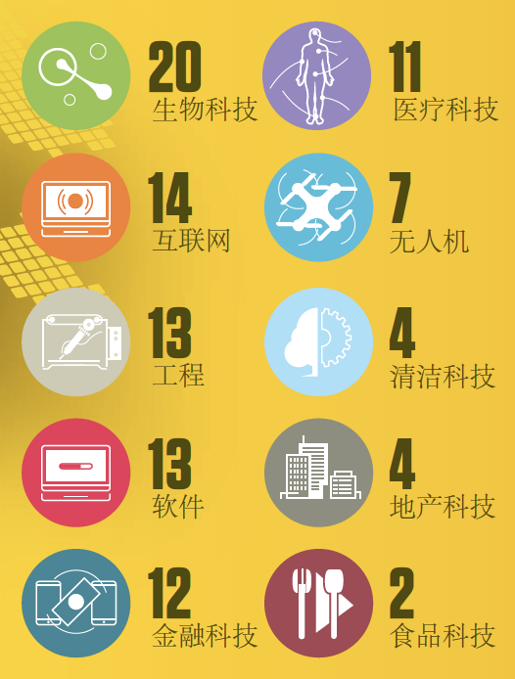

Global investment for world-leaders
International investor appetite for Swiss start-ups continues to grow. Since 2011, 397 start-ups have ranked in the TOP 100 and to date they have attracted nearly CHF 4.3 billion in investment, an average of about CHF 11 million each. Over the past year, many of the TOP 100 start-ups have made headlines with financing rounds in the tens of millions, while others such as Flyability, which leads the ranking this year, are establishing themselves as world leaders in fast-growing markets.

Jordi Montserrat, Co-founder and Managing Partner at Venturelab expressed, “This has been the TOP 100’s objective from the start: to highlight the most-promising Swiss start-ups, so that they appear on the radar of investors and talent scouts around the world. A mission accomplished in Switzerland and now also internationally, with print versions of the TOP 100 Startups magazines in English and Chinese distributed around the world.”

Swiss startups in China

The booming Chinese innovation ecosystem is an ideal match for many Swiss startups as China’s hunger for deep-tech innovation offers them stellar opportunities for fundraising, connecting with partners, manufacturers or investors, and tapping into its colossal market. swissnex China, the Science Consulate of Switzerland in China, is responsible for helping the growing number of Swiss innovators and entrepreneurs to find collaborations, funding or fresh ideas in China.

Dr. Felix Moesner, Science Consul & CEO at swissnex China expressed, “Our flagship Venture Leaders China program in partnership with Venturelab has been an exemplary platform to this end - having already seen 6 tremendously successful editions with many of its alumni featured amongst the TOP 100 Swiss Startup Award, including this year’s winner Flyability. Within these pages we invite you to discover the top Swiss startups with the ambition to shape the world of tomorrow.”

swissnex China also had the pleasure of supporting Bestmile (5), Piavita (8), Advanon AG (9), Astrocast (12), Crypto Finance AG (17), Cellestia Biotech (19), Fixposition (20), Insolight (28), Loanboox (41), MaxWell Biosystems (33), Nomoko (42), Peripal AG (49), GRZTechnologies (55), InterAx Biotech AG (66), Spectroplast AG (80), ScanTrust (82), TwentyGreen AG (95) through Venture Leaders China, Venture Leaders Fintech, #SwissTech Pavilion at CES Asia, and Innosuisse Camp. From November 3 to 9, 2019, 10 top Swiss Fintech companies will attend the Venture Leaders Fintech 2019 roadshow in Hong Kong and Shenzhen co-hosted by Venturelab and swissnex China.

To download magazine in English, German, French and Chinese, please visit: https://www.top100startups.swiss/

######

About swissnex China
关于瑞士联邦政府科技文化中心
swissnex China is the Science Consulate of Switzerland in China, which builds bridges by connecting Switzerland and China in education, research and innovation. By crossing conventional boundaries, we offer a platform to foster collaboration and creativity for inspiring research and ground-breaking innovation.
瑞士联邦政府科技文化中心（swissnex China）是瑞士驻中国的科学领事馆，在中瑞的教育、研究和创新方面搭建了桥梁。通过突破传统的界限，我们提供了一个促进合作和创造力，激发研究和突破性创新的平台。欲了解更多，欢迎访问：

官方网站: https://www.swissnexchina.org/
领英: https://www.linkedin.com/company/swissnex-china/
微博: https://weibo.com/swissnexchina
Twitter: https://twitter.com/swissnexChina

Media Contact:

Mr. Danli ZHOU
Head of Marketing & Communications
swissnex China
Tel: + 86 21 6235 1889
Email: danli.zhou@swissnexchina.org

