Press release

Shanghai October 22, 2020

10 Swiss Fintech Startups Get Ready to Accelerate Their Growth in Asia with Venture Leaders

Shanghai, October 22, 2020 – Venture Leaders Fintech 2020, co-organized by Venturelab and swissnex China, will kick off their pitching and fundraising roadshow virtually on October 27th through the Virtual Demo Day as well as to explore the booming fintech ecosystem of the Greater Bay Area, including participation in the virtual edition of the Hong Kong Fintech Week, Asia’s global fintech conference.

For the second edition of Venture Leader Fintech in Hong Kong, swissnex China is proud to be supporting a high-quality delegation of top Swiss fintech startups for a pitching and fundraising roadshow with business workshops, startup exhibition and investor meetings all delivered in a virtual format through Virtual Demo Day and Hong Kong Fintech Week 2020. It offers the startups unparalleled exposure and insight into the booming local fintech ecosystem of Hong Kong as part of the Greater Bay Area (GBA), along with learning about business opportunities, how corporate affairs work, pitching to investors and getting insights from experts.

The Venture Leaders program has introduced the Swiss National Startup Teams to leading investors and potential customers in technology hubs in Silicon Valley, Boston, New York, China and Barcelona for 16 years. Swiss fintech startups raised more than CHF 133 million last year, and the sector’s leaders plan to keep growing and going global.

“Switzerland hosts over 370 fintech startups operating in diverse areas including investment management, banking infrastructure, deposit & lending, and payment. We are proud to support ten leading fintech startups among them to interact with the local fintech ecosystem and exchange with investors, experts and potential partners.” said Dr. Felix Moesner, Science Consul & CEO of swissnex China, the Science Consulate of Switzerland.

Venture Leaders Fintech alumni comprise high-flying startups such as Qumram (acquired by Dynatrace), Knip (acquired by Digital Insurance Group), Carbon Delta (acquired by MSCI), Algotrader, CreditGate24, Crypto Finance, Lend, Sonect, and Tradeplus24.

“The 10 Venture Leaders Fintech 2020 illustrate that Switzerland is a strong contender for transforming the banking and insurance industry. Four of last year’s participants each closed a substantial financing round after the roadshow, and I’m looking forward to laying the foundation for this year’s team by introducing them to international investors,” said Stefan Steiner, co-managing director of Venturelab.

Jan Brzezek, Founder and CEO of Crypto Finance and Venture Leader Fintech 2019, explains: “If you think of expanding to Asia or just want to better understand the potential market there, this program is a must for you! It’s a one-week packed program with lots of pitches, meetings, and insights.” Crypto Finance was ranked 16th at the TOP 100 Swiss Startup Award 2020, and following the Venture Leaders Fintech roadshow, the Zug-based startup completed a financing round of more than CHF 14 million from investors in Europe and Asia, which will further intensify its international expansion.

The Venture Leaders Fintech roadshow 2020 is organized by Venturelab and swissnex China and supported by EPF Lausanne, ETH Zurich, IMMOMIG, PostFinance, TX Group, Walder Wyss, Presence Switzerland, and the Canton of Zurich.

For more information about Venture Leaders Fintech 2020 or register for the Virtual Demo Day, please visit: https://www.swissnexchina.org/en/event/venture-leaders-fintech-2020/

Venture Leaders Fintech winners 2020

Curio Capital AG (CurioInvest) | Rey Fernando Verboonen | www.curioinvest.com | Zug
Collectibles as an alternative investment have historically outperformed established indexes, yet it remains extraordinarily challenging to invest in them. CurioInvest provides a gateway to purchasing fully assessed and exclusively secured ultra-rare cars─or invest in profit-sharing digital assets that trade like stocks.

Cybera Global AG | Nicola Staub | www.cybera.io | Zurich
cybera. global combines unique industry knowledge and professional insights with the latest technology to build a fintech platform that prevents financially motivated cybercrime for financial institutions and governments.

eCollect AG | Marc Schillinger | www.ecollect.org | Baar
eCollect is a fintech-driven startup with an end-to-end, cross-border receivables management platform that was developed in-house. eCollect makes use of best-in-class AI solutions to turn traditional invoicing, dunning, and debt collection into an innovative, fully digitalized experience for all industry sectors and their clients.

flov technologies AG | Anton Golub | www.flovtec.com | Zug
flovtec is a Swiss technology company specializing in providing liquidity to tokens and exchanges in the growing digital asset space. The flovtec platform and algorithms deliver highly scalable liquidity solutions, making digital assets attractive to investors while complying with the Swiss regulatory framework.

SIBEX AG | Daniel Haudenschild | www.sibex.io | Zug
SIBEX is the most intuitive and straightforward way for users to trade between a network or chat group. The SIBEX Personal Server is a cloud trading desk that allows users to trade immediately, and without a middleman, on the public blockchains of BTC and Ethereum and access their server from anywhere.

SwissBorg Invest SA | Cyrus Fazel | www.swissborg.com | Lausanne
SwissBorg is decentralizing wealth management by making it fun, fair, and community centric. Their showcase product, the Wealth App, allows users to buy, sell, and exchange digital assets - with features like AI-powered asset analysis and portfolio analytics to help them make smart investment decisions.

Teylor AG | Patrick Stäuble | www.teylor.io | Zurich
Teylor brings small business lending into the 21st century by automating and digitalizing the entire commercial credit process. The company uses its technology to provide one of the fastest business loans and offers banks a SaaS solution to digitalize their own lending processes.

Vima Link SA | Raphaël Héraïef | www.vima.swiss | Martigny
Based on 10 years of research at the Idiap, Vima Behavioural AI can improve credit score systems from a short 1-3 minutes video presentation of borrower applicants. The AI platform can replicate expert assessments to understand traits such as conscientiousness, which correlate to financial risk-taking and capabilities to plan and repay. The system is transparent, minimizes bias, and improves risk-taking balance.

Wecan Tokenize SA | Mathieu Saint-Cyr | www.wecantokenize.com | Geneva
Wecan Tokenize (WCT) is the first end-to-end institutional tokenization solution. It aims to use the power of blockchain to digitize assets, making them more liquid and easier to transfer. WCT is focusing on offering the best service for institutional clients so that they can include digital tokens as part of their investment options.

Yova AG | Tillmann Lang | www.yova.ch | Zurich
Yova is the leading digital platform for investing with a sustainability impact. Yova customers invest directly into companies that help solve global problems, e.g., by fighting climate change or by promoting human rights. All investments are professionally diversified portfolios that are designed to deliver an attractive financial return.
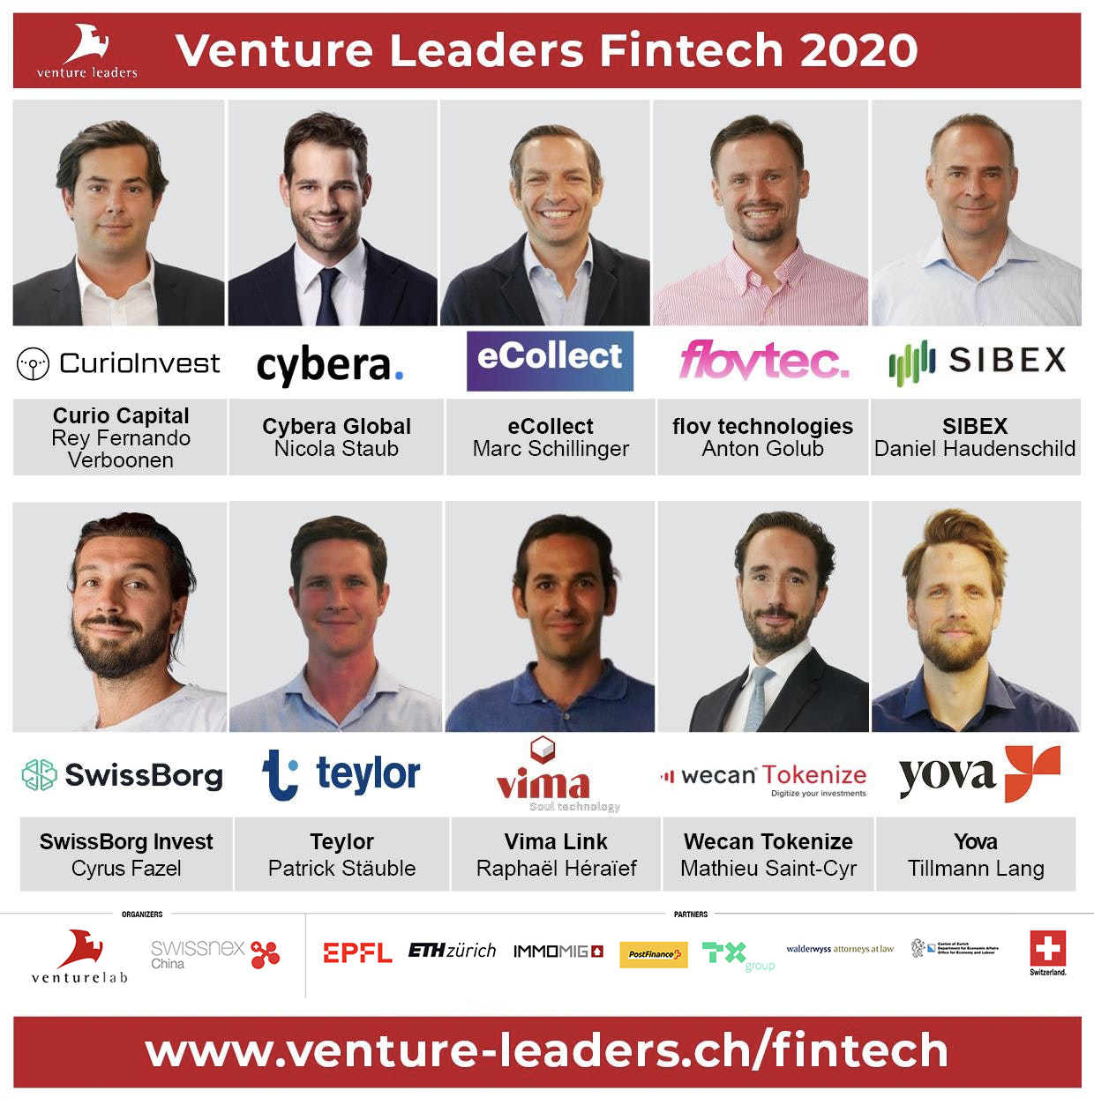

#####

About swissnex China

swissnex China is the Science Consulate of Switzerland in China, which builds bridges by connecting Switzerland and China in education, research and innovation. By crossing conventional boundaries, we offer a platform to foster collaboration and creativity for inspiring research and ground-breaking innovation. For more information, please visit:

swissnex China official website: https://www.swissnexchina.org/
swissnex China LinkedIn: https://www.linkedin.com/company/swissnex-china/
swissnex China Weibo: https://weibo.com/swissnexchina
swissnex China Twitter: https://twitter.com/swissnexChina

Further enquiries:

Mr. Danli ZHOU
Head of Marketing & Communications
swissnex China
danli.zhou@swissnexchina.org
Tel: + 86 21 6235 1889

