Press release

Shanghai February, 2020

Swiss Open Database highlights Science-Driven Innovation

Shanghai, February 2020 – swissnex China, the Science Consulate of Switzerland in China, launches the Science-Switzerland website, an online database devoted to creating awareness about future-oriented, science-driven innovation news and trends coming from Switzerland. The new tool also aims to foster cross-border collaborations between Switzerland and China in the domain of science, technology, research and innovation.

Science-Switzerland is an online database providing executive summaries of top-highlights on new discoveries in science, the latest top-of-the-line technologies and showcasing the innovation strengths of Switzerland. Founded in 2008, Science-Switzerland started out as an online publication dedicated to promoting current and emerging trends and opportunities from Swiss startups, academic and research institutions. With information accrued over a decade, the database provides an informative and engaging digest of aggregated news from across Switzerland’s innovation landscape.

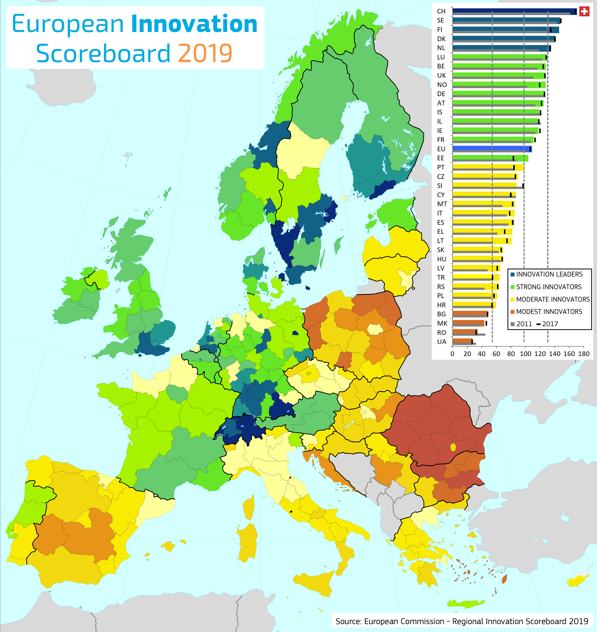
For the past 9 years, Switzerland has been consistently ranked as the world’s most innovative country in the Global Innovation Index published by World Intellectual Property Organization. As a small Alpine nation nestled at the heart of Europe, Switzerland has been dominating regionally as top innovation leader according to the European Innovation Scoreboard published by the European Commission. Swiss startups also have above-average survival rates when compared internationally, at over 80% after the first year. This year, Switzerland will be featured as the Country of Honor at Pujiang Innovation Forum, where Sino-Swiss bilateral cooperation in tech transfer and collaborative multidisciplinary research will be high on the agenda.

With the goal of fostering collaboration and exchange between Switzerland and other prominent global innovation hubs like China, the database provides an informative peek into the top innovation coming out of Switzerland, and is open for use by researchers, entrepreneurs, policymakers, university professors, students and the general public to gain insights into cutting-edge Swiss science & technology developments. Powered by the vast Science-Switzerland database, the website is populated with over a decade of articles sorted by topics, source and dates. The tool also allows users to generate instantaneous reports on specific fields or topics, and all content is easily shareable via email or social media.

The Science-Switzerland database is produced by swissnex China as part of the swissnex Network – Switzerland’s global network for education, research and innovation, and supported by the State Secretariat for Education, Research and Innovation, Innosuisse, ETH Board, the Swiss Federal Office of Energy and Presence Switzerland.

#####

About swissnex China

swissnex China is the Science Consulate of Switzerland in China, which builds bridges by connecting Switzerland and China in education, research and innovation. By crossing conventional boundaries, we offer a platform to foster collaboration and creativity for inspiring research and ground-breaking innovation. For more information, please visit:

swissnex China official website: https://www.swissnexchina.org/
swissnex China LinkedIn: https://www.linkedin.com/company/swissnex-china/
swissnex China Weibo: https://weibo.com/swissnexchina
swissnex China Twitter: https://twitter.com/swissnexChina

Further enquiries:

Mr. Danli ZHOU
Head of Marketing & Communications
swissnex China
danli.zhou@swissnexchina.org
Tel: + 86 21 6235 1889

