Media release

Shanghai 12 June, 2020

20 SwissTech startups zoom onto the world stage

Continuing the tradition of SwissTech startups pitching in the framework of the Consumer Electronics Show CES ASIA, 20 Swiss tech-driven startups took the global stage at the SwissTech Pitchinar world premiere on 10 June, 2020. Organized by swissnex China in collaboration with SwissTech, CES ASIA and Venture Leaders, with the support of institutional partners, the SwissTech Pitchinar serves as a testament to Switzerland’s leading position as a center of technology and innovation.

Shanghai, 12 June, 2020 – On June 10, SwissTech Pitchinar, a pitching competition in webinar format, was joined by 20 leading Swiss startups in the fields of Advanced Instrument, Artificial Intelligence, Augmented/Virtual Reality, Biotech, Blockchain, Cybersecurity, Energy, Fintech, HealthTech, IoT, Robotics, Software and VehicleTech. This first-of-its-kind virtual event held on Zoom received overwhelming interest from top-level audiences with more than 950 registrants from top universities, blue-chip companies, media and 238 investors with strong interest in Swiss technology and innovation, seeking opportunities for investment, partnerships and project cooperation.

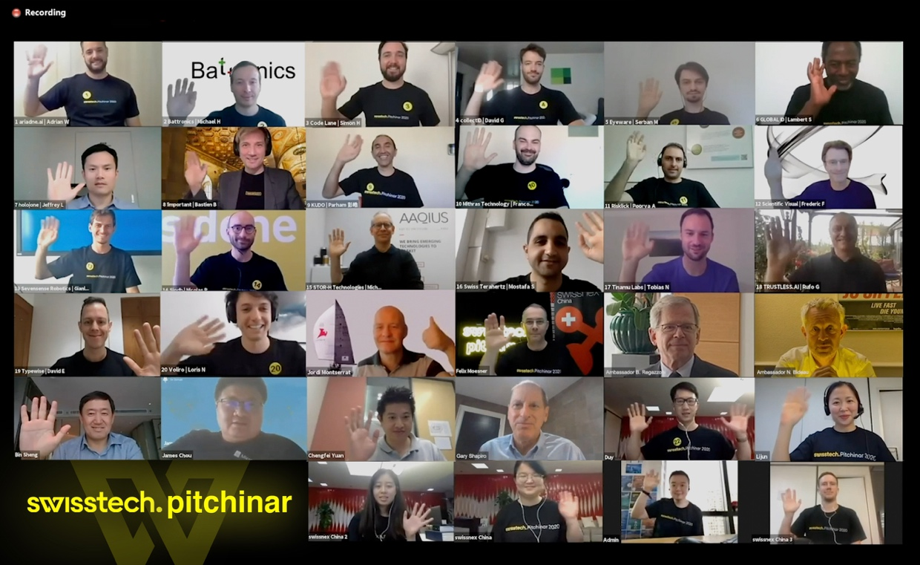

View event recording
The virtual pitching competition featured 90-second pitches from each of the startups, providing them with a platform to spotlight their products and services with prospective investors, partners and industry experts. Ambassador Nicolas Bideau, Head of Presence Switzerland, and Gary Shapiro, CEO of Consumer Technology Association, which organizes CES ASIA and Las Vegas, delivered the keynote messages.

Mithras Technology, a startup that developed wearable technology turning human body heat into usable electricity, emerged as the champion among the 20 competing startups. Eyeware, STOR-H Technologies, and Swiss Terahertz were chosen by the jury as finalists. The event reached its high peak as Swiss Ambassador to China Bernardino Regazzoni virtually awarded the trophies to the selected startups. The outstanding performance of all participating startups demonstrate the strength of the Swiss innovation ecosystem and the excellence of the world-class Swiss universities.
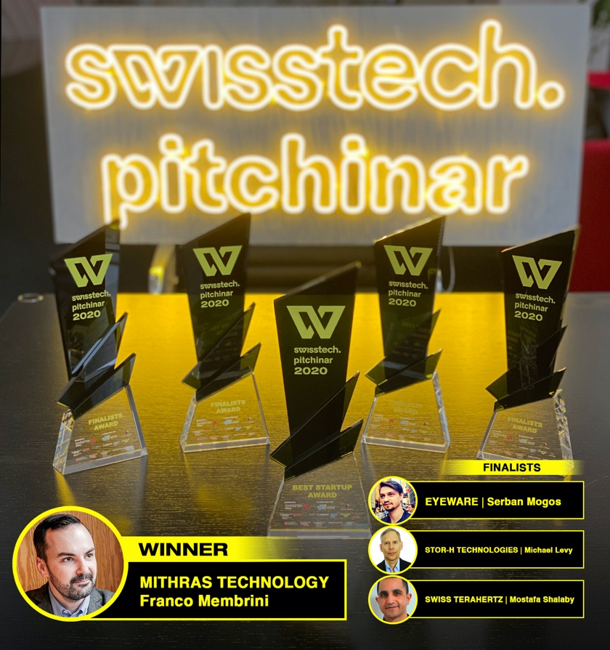

“This was completely unexpected. We feel very proud and honored to have won the first SwissTech Pitchinar 2020! We already received lots of positive feedback from people reaching out to us, which could result in very interesting leads and this highlights the inestimable worth of such events…”, said Franco Membrini, Founder & CEO of Mithras Technology, “We would like to thank the team of swissnex China for an outstanding organisation and wish all the presented startups best of success!”

“Today, we pioneered a powerful virtual platform for Swiss startups to establish game-changing partnerships with investors, mentors, experts, potential business partners and highly-engaged audiences on a global scale: an unprecedented way to add value and build bridges”, said Dr. Felix Moesner, Science Consul and CEO of swissnex China. “We saw overwhelming interest in our DeepTech startups and wish them every success with their many follow-ups.”

SwissTech Pitchinar 2020 is organized by swissnex China in collaboration with SwissTech, CES ASIA and Venture Leaders, and in partnership with EPFL, ETH Zurich, Greater Zurich Area, Innovaud, Swisscom and Venturelab. The SwissTech Campaign partners are Presence Switzerland, Switzerland Global Enterprise, Innosuisse, digitalswitzerland and swissnex Network.

Further information on SwissTech Pitchinar 2020:
www.cesasia.swissnexchina.org

SwissTech Pitchinar 2020 Startups:
ariadne.ai | Adrian Wanner | www.ariadne.ai Biotech
High-throughput biomedical image analysis

Battronics | Michael Hess | www.battronics.com Vehicle Tech
Battery tech knowledge superpositioning to accelerate research on Li-ion batteries

Code Lane | Simon Heinzle | www.codelane.ch AR/VR
Emotion-powered human-like 3D avatar rendered in real-time using artificial intelligence

collectID | David Geisser | www.collectid.io Blockchain
Authenticity and transparency through Blockchain-Technology

[Finalist] Eyeware | Serban Mogos | www.eyeware.tech Artificial Intelligence
Remote eye tracking software for laptops, smartphones, cars and more

GLOBAL ID | Lambert Sonna | www.globalid.swiss Cybersecurity
Leading B2B digital authentification solutions provider

holo|one | Jeffrey Li | www.holo-one.com AR/VR
The Mixed Reality Standard for Enterprises

!important | Bastien Beauchamp | www.important.com Vehicle Tech
The Safety Belt for Pedestrians

KUDO | Parham Akhavan | www.kudoway.com Software
Multilingual Video Conferencing and Live Events for Businesses

[Winner] Mithras Technology | Franco Membrini | www.mithras.tech IoT
Wearable technology turning human body heat into usable electricity

Risklick | Poorya Amini | www.risklick.ch HealthTech
AI solutions enabling analysis and mitigation of clinical trial risks in protocol design phase

Scientific Visual | Frederic Falise | www.scientificvisual.ch Advanced Instrument
Quality control instrument for semiconductor
Sevensense Robotics | Gianluca Cesari | www.sevensense.ch Robotics
Empowering mobile robots to move into crowded and fast-changing spaces

Siodb | Nicolas Penot | www.siodb.io Software
Open Source relational database that secures your data by default

[Finalist] STOR-H Technologies | Michael Levy | www.aaqius.com Energy
The global energy standard for zero-carbon mobility
[Finalist] Swiss Terahertz | Mostafa Shalaby | www.swissterahertz.com Advanced Instrument
High tech terahertz laser technologies for security and quality control

Tinamu Labs | Tobias Nägeli | www.tinamu-labs.com Robotics
Using drones for automated data acquisition in all environments

TRUSTLESS.AI | Rufo Guerreschi | www.trustless.ai Fintech
Radically-unprecedented security and privacy for your private digital life, e-health and e-banking

Typewise | David Eberle | www.typewise.app Artificial Intelligence
Secure and intelligent human-machine interface

Voliro | Loris Niederberger | www.voliro.com Robotics
Revolutionizing work at height

#####

swissnex China official website: https://www.swissnexchina.org/

swissnex China LinkedIn: https://www.linkedin.com/company/swissnex-china/

swissnex China Weibo: https://weibo.com/swissnexchina

Further enquiries:

Mr. Danli ZHOU
Head of Marketing & Communications
swissnex China
danli.zhou@swissnexchina.org
Tel: + 86 21 6235 1889

